***• What is the problem domain or context of the visualization under consideration?***

The amount of revenue of movies in movie theaters between 1986 and 2008.

***• Which tasks can be achieved with this visualization?***

Showing the revenue and popularity over time of movies between 1986 and 2008 in one view.

***• Tufte’s principles of graphical integrity:***

***– Are the scales appropriately labeled?***

The exact amount of revenue is not really clear. Furthermore, there is a visual bias towards more popular movies; smaller movies are hardly visible nor labeled.

***– Is the Lie factor high?***

The lie factor is the divide between the visual effect in a graph versus the effect visible in the data. In this graph, the total revenue is simulated by the total surface of a movie, while the graph gives the impression that the revenue is related to the length of the curves. Also, only a couple of movie titles are shown in the graph and thus creates more attention towards bigger movies. The color scale is also non-linear.

***– Does the visualization show data variation and not design variation?***

It shows the differences between movies in box office revenue, however, the design of the graph favours bigger movies because they stand out in the graph, and it is harder to select and view smaller movies.

***• Tufte’s visualization design principles, are they adhered to?***

***– Maximize the data-ink ratio.***

In this visualisation a lot of ink is used to only show a small amount of data. A lot of ink is wasted due to the fact that at the end of every movie surface the effect on the revenue gets so small, that it’s hardly noticeable.

***– Avoid chart junk.***

The clickable chart surfaces are not necessary, because we are not interested in seeing a movie summary but total revenues, screen time et cetera.

***– Increase data density.***

The data density is well formatted, but it would be better to have an option to view movies with a certain revenue to separate movies from each other.

***– Layer information.***

Very little information is shown when one of the individual graphs is selected. No total revenue / screen-time / cost etc.

***• Graphic design principles:***

***– How is contrast used? What kind of contrast is used?***

Contrast is used to distinguish movies by revenue. Color contrast based on revenue scales. Darker colors make more impact, this is used to stand out the movies with a higher revenue.

***– How is repetition used?***

Both the color and the shape of the graph is repeated throughout the design.

***– How is alignment used?***

In this graph it is very difficult to compare surfaces with each other because they have different shapes. A lot of charts have overlay of other charts, that makes the alignment inaccurate.

***– How is proximity used?***

Movies that are close to each other were in the theaters in the same time.

***• Comment on the visual encodings that are used.***

***– Which visual encodings are used?***

Color for differences in revenue.

***– Are the visual encodings appropriate?***

The colors used are but there are problems with the scale.

***• Comment on subjective dimensions such as aesthetics, style, playfulness and vividness.***

The visualization is somewhat playful because of the many colors and because of the smooth transition of graphs over time. The vividness and style is nice because you directly see a lot of data in a rather small window. However when you look more closely you can hardly separate the movies from each other.

***• What is the intended goal of the visualization and is that goal achieved?***

The goal is to show off the box office revenue of movies over a time scale. The goal is partly achieved. When looking at the graph it can be confusing that the length of the movie in the graph does not represent a bigger box office. It is about the total surface area of the movie in the graph. Large parts of the surface area of movies are also overlapped by other movies. This makes the graph look very cluttered with data.

***• Are there any things you would do differently, and why?***

I would either split the chart into multiple ones (small, regular, large) to increase visibility of individual movies and suppress the bias towards more successful movies. We would also put more relevant data inside the labels of the movies: total revenue, runtime, peak, average etc. instead of summaries which are wildly differing.

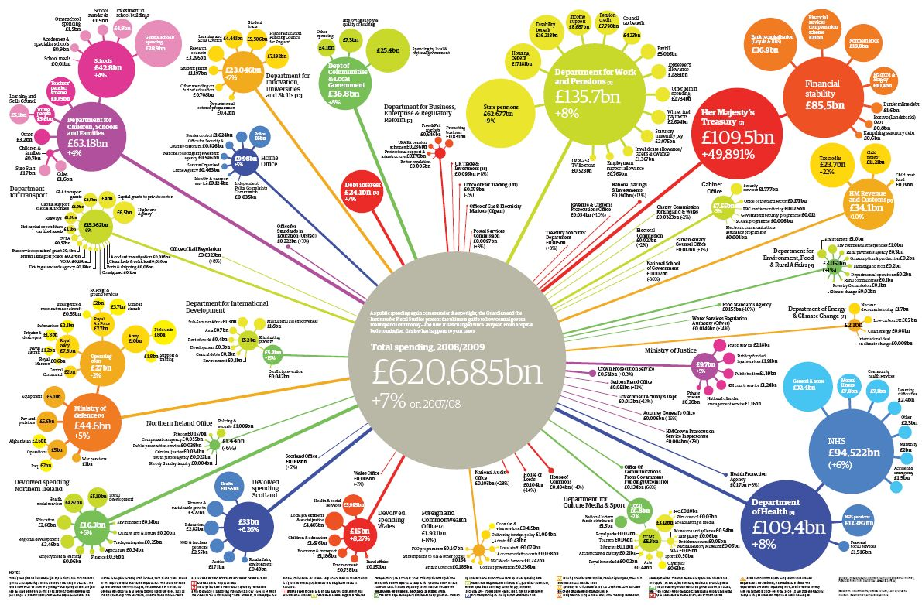

(<http://www.improving-visualisation.org/img_uploads/2009-12-04_Fri/2009124163835.jpg>)

**Size:** Size is used to show an order, where the total collection of bubbles is represented by the center one and every next branch is part of its parent. However, guessing the relative difference in surface of circles is extremely hard, it is thus quite difficult to know what percentage of the total budget is used for each bubble based on the size alone.

**Color:** The colours that are used in the graph overlap sometimes. For example: the middle left bubbles share almost the same colour as the upper right ones and multiple comparable blues are used.Color is used to order the different bubbles and then different shades of the same colour are used in a relative fashion.

Also the colours are not consistent. For some branches, a different colour is used while others share the same one as the original bubbles.

**Tasks:**

1. Show relative difference between expenditure of government departments.
2. Show the way the finances are ordered: x, y and z are part of the ministry of A.
3. To make government expenditure accessible and readable for all people.

These tasks are all largely achieved with the graph. The sizes of the circles achieve most of task 1, they give a direct insight in the amount of expenditure of different government departments. On further inspection, the smaller departments can be recognised as being part of bigger ministries. So we see that task 2 is achieved. Overall we see that this visualization is largely accessible to all people because we do not have to look at many numbers in for example a budget statement.